**Worksheet activity 1_week 1**

**By the end of these exercises, you should be able to:**

* Use Python IDLE to write short Python programs.
* Use print() function to display text on screen.

**New Terminologies:**

* Escape sequences – e.g. \n (new line), \t (tab), \\ (backslash)

Programming Tip:  
Pay attention to detail when you read and type code. It will help you learn faster and save you a lot of time and errors

# Exercise 1—Part 1—Opening IDLE

|  |  |
| --- | --- |
| Open Python IDLE  (If there are multiple Python IDLEs, make sure you choose the one that is the latest or **version 3 or above**.) |  |
| Type in the following code after >>> and press enter!  **print("Game Over")** |  |
| Did you get any errors? |  |
| Try the code with and without the brackets. What happens? | SyntaxError: Missing parentheses in call to 'print'. Did you mean print("Game over")? |
| Try the code with and without the quotes. What happens? | SyntaxError: invalid syntax |
| Common problems | * + 1. The command “print” should be in lower case.     2. Forgetting opening or closing brackets.     3. Forgetting an opening or closing quote.     4. Forgetting both quotes. |

# Exercise 1—Part 2—First Program

|  |  |
| --- | --- |
| Create a folder called **Prog Funds programs** on your home drive. Under this, create a subfolder called **Day1**.  This is where you will store all of your program code for today. |  |
| Open IDLE |  |
| Open a new window. |  |
| Type in the following Code in the new Window.  **print("Game Over")**  **print("Press the enter key to exit the game")** |  |
| Save the file in S:\Prog Funds\Day1\Exercise1.py |  |
| Run the code.  Select Run> Run Module  [Run Module F5] |  |
| Did you get the right output? | Yes |
| Did you get errors? | No |
| Read the error messages carefully, they usually tell you what is wrong. | No |
| What does the input statement do? | There is no Input statement in this exercise.* |

# Exercise 2—Print Statement.

Write a program that displays your name inside a box on the screen, like this:

****************

***** JACK *****

****************

1. Open IDLE
2. Open a new file.
3. Save the file as S:\Prog Funds\Day1\Exercise2.py
4. Create a program with 3 print statements.
   1. You should be able to work this out based on the previous exercise.
5. Run the program.
6. Did you get the desired output?
   1. Did the print statement behave in the way you expected?-Yes
   2. What do you think a single print statement does?

Ans-Single print statement presents whatever in the bracket with the quotes.

# Exercise 3—Haunted House Game.

print("Haunted House")

print("=============")

print ("Game Over")

print("Press the enter key to exit the game")

input()

1. Type in the above code in a new file.
2. Save the file in S:\Prog Funds\Day1\Exercise4.py
3. Run the code.
4. Did you get the right output?

Yes

1. Did you get errors?

No

* 1. Read the error messages carefully, they usually tell you what is wrong.

No error message.

# Exercise 4—Quotes in Quotes…

1. Put a copyright notice at the bottom of your code, before the “press enter key” instruction… (There are many ways to print a copyright symbol ©, one way is to copy & paste it from Microsoft Words)
2. Save the file as Exercise7.py.

print("Haunted House")

print("=============")

print ("Game Over")

print ("© 2015, Unitec New Zealand 'ISCG5420 Programming Fundamentals'—your name")

print("Press the enter key to exit the game")

input()

1. Change that code to:

print ('© 2015, Unitec New Zealand "ISCG5420 Programming Fundamentals"—your name')

1. This demonstrates that you can:
   1. Use single and double quotes.
   2. What do you notice if you use the following code?

print ('© 2015, Unitec New Zealand 'ISCG5420 Programming Fundamentals'—your name')

It shows Invalid syntax

1. Remember, the computer is dumb! So it does not understand where the quote begins and ends!

# Exercise 5—Escape Sequences.

1. Experiment with escape sequences.
2. Open “Exercise4.py” and save it as “Exercise5.py”
3. Change the copyright line to:

print ("\n\n\n© 2015, Unitec New Zealand 'ISCG5420 Programming Fundamentals'—your name")

What happened? What does \n mean?

(/n) means a “newline” and it shows us that n is used as a term for the addition of a new line.

1. Change the copyright line to:

print ("\t\t© 2015, Unitec New Zealand 'ISCG5420 Programming Fundamentals'—your name")

What happened? What does \t mean?

\t means TAB

1. Change the copyright line to:

print ("\t\t© 2015, Unitec New Zealand \"ISCG5420 Programming Fundamentals\"—your name")

* What happened? What does \" do…
* Try the code without the \" and use double quotes instead.
* The \ character is called the escape character.
* How can we print the \ character if it is an escape character? “\\”! Cool eh?
* Go online and search for “escape sequences python”
  + Knowing this type of language helps you search.
  + Don’t be too daunted by all of the jargon and technical terms online. We will be learning the terminology, so you can find good information to help you solve problems.

# Exercise 6—Triple Quoted Strings

print("Haunted House")

print("=============")

print ("Game Over")

1. Create a new file Exercise6.py
2. Copy the code above into the new program
3. Add the following code to the end of the program.

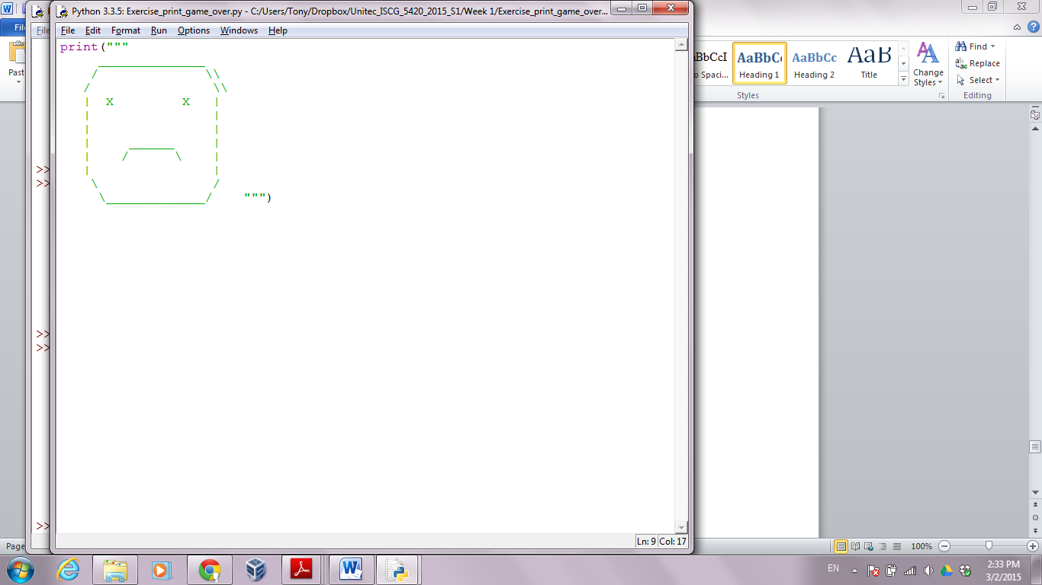

1. Why do we use triple double quotes (""") in this example?

To create strings that span multiple lines, triple single quotes ''' or triple double quotes """ **are used to enclose the string**. ''' This string is on multiple lines within three single quotes on either side

1. Give it a few minutes to try to print the same face out by using single double quote instead of triple double quotes?
2. Do you need the double slashes at the end of the 2nd and 3rd lines? Does the program work if you have only one slash instead?
3. Did you get errors?
   1. Too few quotes?

* 1. Missing brackets?

* 1. Spelling of “print”

Getting this error message:-

Traceback (most recent call last):

File "C:/Users/shwet/OneDrive - Unitec NZ/Desktop/NZDCS/HTCS6702 - Cryptography/Soheil's class/Prog Funds programs/Day1/Exercise6.py", line 5, in <module>

prnt ("""

NameError: name 'prnt' is not defined

* 1. Case of “print”

Traceback (most recent call last):

File "C:/Users/shwet/OneDrive - Unitec NZ/Desktop/NZDCS/HTCS6702 - Cryptography/Soheil's class/Prog Funds programs/Day1/Exercise6.py", line 5, in <module>

Print ("""

NameError: name 'Print' is not defined

* 1. Remember to read the errors and work out what the computer is telling you.